**Vivekanand Education Society’s Institute of Technology**

**Department of AI&DS Engineering**



**Subject: Social Media Analytics**

**Class: D16AD**

| ROLL NO: **30** | NAME: [**SUHANEE KANDALKAR**](mailto:2021.suhanee.kandalkar@ves.ac.in) | | |
| --- | --- | --- | --- |
| EXPERIMENT NO:**1 B** | TITLE: Comparative Social Media Analysis of Tools Using Brand24 | | |
| DOP: |  | DOS: |  |
| GRADES: | LOs MAPPED: | | SIGNATURE: |

**Aim :**

Comparative Social Media Analysis of Tools Using Brand24

**Theory :**

## Comparison of Brand24 & GoogleTrends:

### 1. Overview of Both Tools

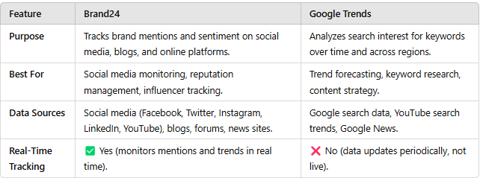

### 2. Data Collection & Analysis

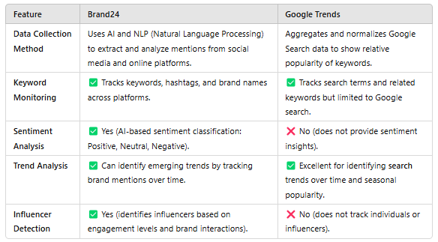

### 3. Visualization & Reporting

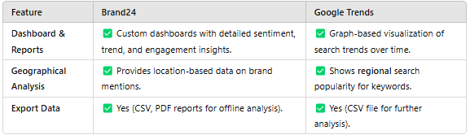

### 4. Use Cases & Applications

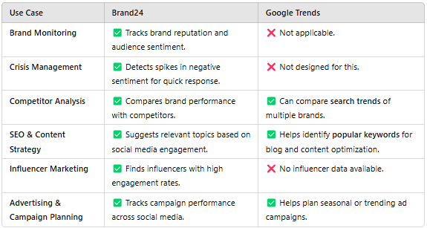

### 5. Pricing & Accessibility

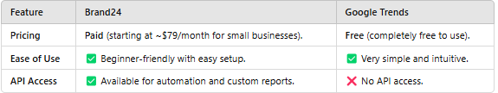

### Final Verdict: Which Tool to Use?

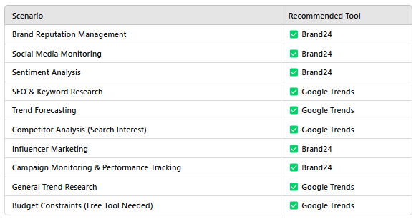

Brand24 Comparison between Brands of productivity tools   
  
1. Google Workshop   
2. Notion  
3. Evernote  
4. Asana  
5. Trello

## Mentions and Reach

Google Workspace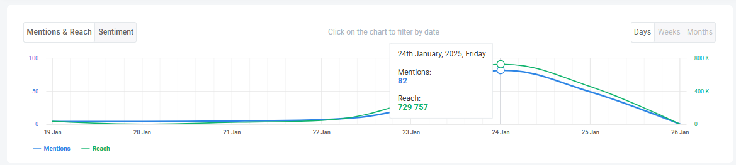

Notion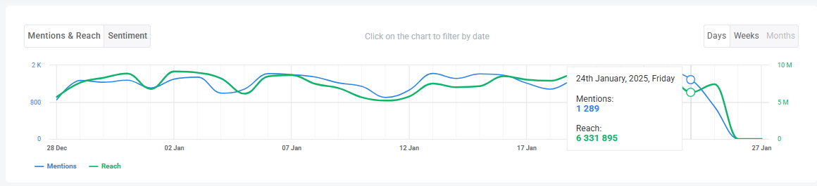

Evernote

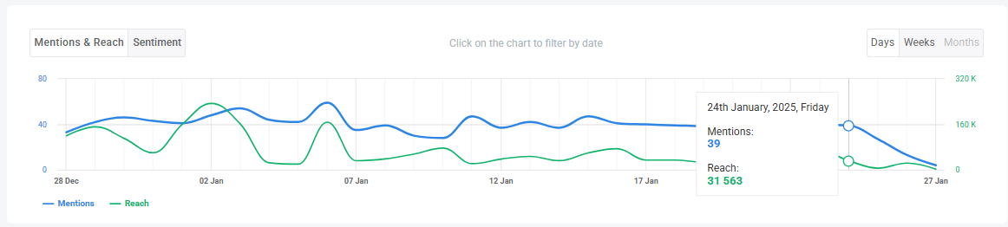

Asana

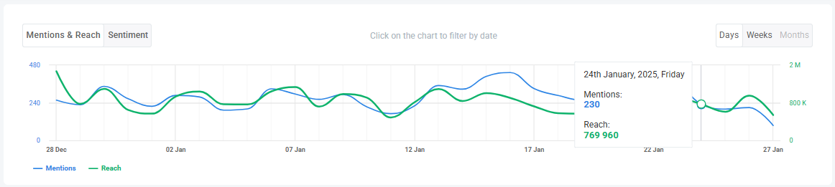

Trello

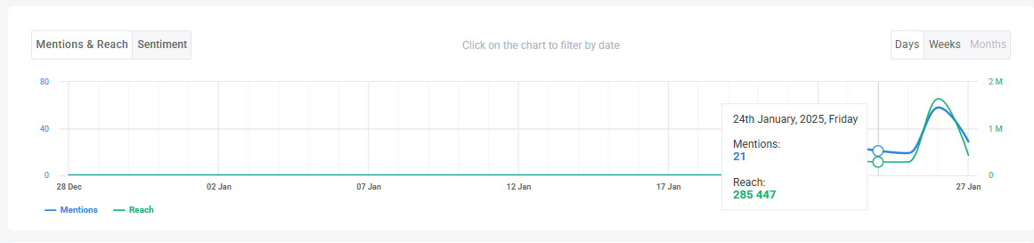

## Sentiment Analysis Google Workspace

Notion

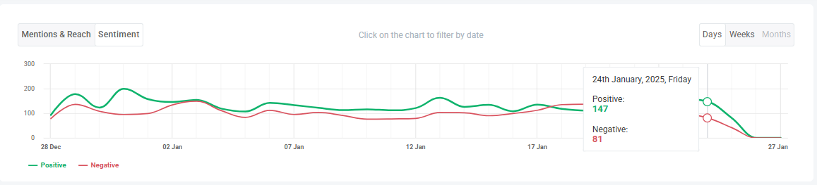

Evernote

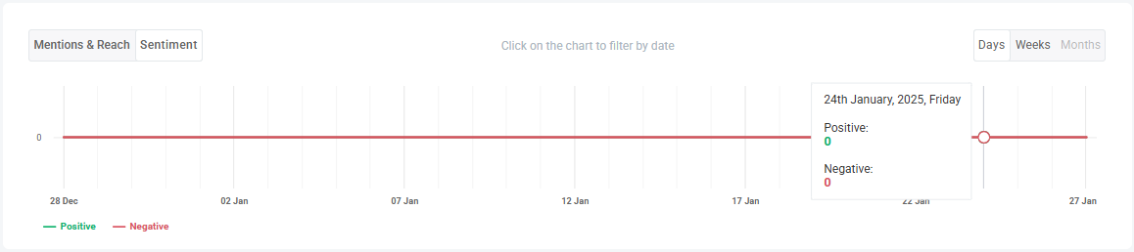

Asana

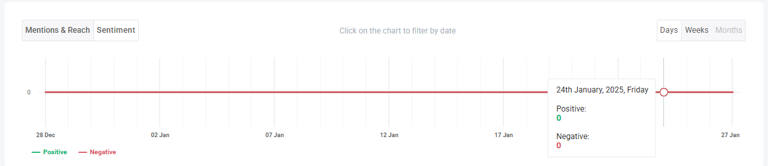

Trello

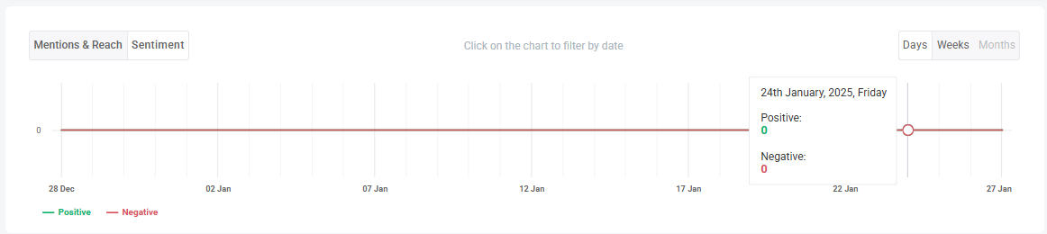

### **Conclusion**

In this **Social Media Analytics (SMA) experiment**, we conducted a **comparative analysis** of five productivity tool brands—**Google Workspace, Notion, Evernote, Asana, and Trello**—using **Brand24**. The analysis was based on three key metrics:

* **Mentions & Reach** – To assess the overall online visibility and engagement of each brand.
* **Sentiment Analysis** – To determine the general perception (positive, neutral, or negative) of each brand in online discussions.
* **Google Workspace** – **Highest mentions & reach**, but mixed sentiment due to pricing concerns.
* **Notion** – **Moderate mentions**, **high positive sentiment**, praised for flexibility & collaboration.
* **Evernote** – **Low engagement**, mixed-to-negative sentiment due to pricing & competition.
* **Asana** – **Strong performance** in mentions & sentiment, widely appreciated for task management.
* **Trello** – **Moderate mentions**, **highly positive sentiment**, valued for team collaboration & ease of use.

Our findings suggest that while **Google Workspace dominates in reach and visibility**, tools like **Notion, Asana, and Trello** maintain strong positive sentiment among users. **Evernote appears to struggle** in both engagement and sentiment, indicating potential brand perception challenges.